Table of contents
- Executive Summary………………………………………………………………………………………………………………. 3
- Methodology………………………………………………………………………………………………………………………… 3
  - Data Description………………………………………………………………………………………………………………… 3
  - Data Exploration………………………………………………………………………………………………………………… 4
  - Data Manipulation…………………………………………………………………………………………………………….. 5
- Data Modeling……………………………………………………………………………………………………………………… 5
  - Data Modeling…………………………………………………………………………………………………………………… 5
3.1(a) Logistic Regression……………………………………………………………………………………………………….. 5
3.2(b) Decision Tree………………………………………………………………………………………………………………… 7
3.3(c) Random Forest……………………………………………………………………………………………………………… 7
- 4(d) Neural Networks…………………………………………………………………………………………………………… 9
- Model Assessment……………………………………………………………………………………………………………… 10
  - Confusion Matrix Graphs…………………………………………………………………………………………………. 10
  - Model Results………………………………………………………………………………………………………………….. 11
- Conclusion………………………………………………………………………………………………………………………….. 12
- Future Recommendations………………………………………………………………………………………………….. 13
- References…………………………………………………………………………………………………………………………. 13
- Appendix……………………………………………………………………………………………………………………………. 13

1.Executive Summary
Every country has its own unique local taste and cuisine. In today’s world, the ease of accessibility of recipes of different cuisines over the internet on various food websites has increased tremendously. We have restaurants serving different cuisines, making food from various parts of the world available in most major cities.
Our aim is to build a model that can accurately predict the category of the cuisine based on the ingredients used in the recipe. The data is from a food website that contains the information of ingredients used in various cuisines. During the predictive modelling process, four classification models-Decision tree, Logistic regression, Random forest, Neural networks are built. The precision, recall and F1 scores are calculated to rate the performance of the models. Based on this, Logistic Regression is found to be the best model.
By doing this, the food website will be more customer friendly and improve the search ability of recipes on the website.

2. Methodology
2.1 Data Description:
Name: What’s cooking
Size: 39775 observations,3 variables
Source: Kaggle
Data Description: Dataset – Predict the cuisine category of a recipe posted on the food website based on the list of ingredients
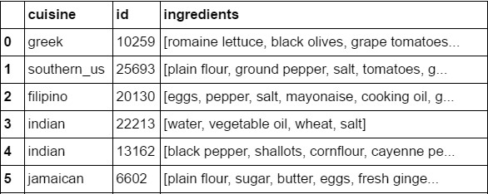
Cuisine- Name of the cuisine
Id- Id of the cuisine
Ingredients- Ingredients used in the cuisine.
2.2 Data Exploration:
The ingredient list is taken as input and the type of cuisine is being predicted with the help of the model. After data exploration, it was found that there is an imbalance in the occurrence of stop words (common ingredients) and rare ingredients. So, more weightage is given to rare ingredients to avoid overfitting.
Text mining Techniques: Text mining, which is sometimes referred to “text analytics” is one way to make qualitative or “unstructured” data usable by a computer. Qualitative data is a descriptive data that cannot be measured in numbers and often includes qualities of appearance like color, texture, and textual description. Quantitative data is numerical, structured data that can be measured. However, there is often slippage between qualitative and quantitative categories. For example, a photograph might traditionally be considered “qualitative data” but when you break it down to the level of pixels, it can be measured. In this dataset, we converted the words of the ingredients into quantitative data using NLTK and SCIKIT package and then develop predictive models further to classify the recipes into different cuisines.
2.3 Data Manipulation:
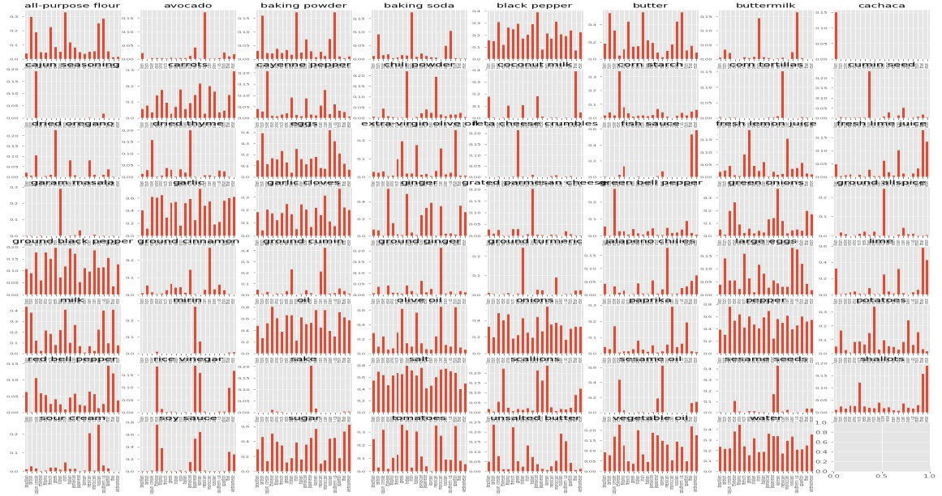
According to the above chart, we found the high degree of uniqueness of each cuisine.
The result exhibits as the following:


3. Data Modeling
3.1 Data Modeling:
Data Modeling is done using Python.
3.1 (a) Logistic Regression: The basic approach is to use the following regression model, employing the notation from Definition 3 of Method of Least Squares for Multiple Regression:
where the odds function is as given in the following definition. Definition 1: Odds(E) is the odds that event E occurs, namely
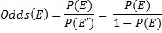
Where p has a value 0 ≤ p ≤ 1 (i.e. p is a probability value), we can define the odds function as
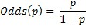
Observation: For our purposes, the odds function has the advantage of transforming the probability function, which has values from 0 to 1, into an equivalent function with values between 0 and ∞. When we take the natural log of the odds function, we get a range of values from -∞ to ∞.
Definition 2: The logit function is the log of the odds function, namely logit(E) = ln Odds(E), or
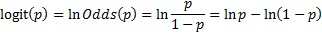
Definition 3: Based on the logistic model as described above, we have
where π = P(E). It now follows that (see Exponentials and Logs):
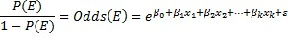
and so
Here we switch to the model based on the observed sample (and so the π parameter is replaced by its sample estimate p, the βj coefficients are replaced by the sample estimates bj and the error term ε is dropped). For our purpose, we take the event E to be that the dependent variable y has value 1. If y takes only the values 0 or 1, we can think of E as success and the complement E′ of E as failure. This is as for the trials in a binomial distribution.

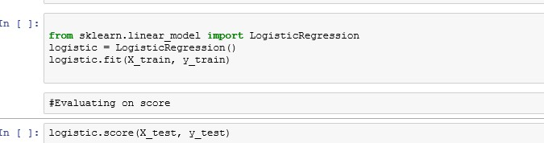
3.1 (b) Decision tree:
Decision trees are produced by algorithms that identify several ways of splitting a data set into branch-like segments. These segments form an inverted decision tree that originates with a root node at the top of the tree. The object of analysis is reflected in this root node as a simple, one-dimensional display in the decision tree interface. The name of the field of data that is the object of analysis is usually displayed, along with the spread or distribution of the values that are contained in that field. A sample decision tree is illustrated in the Figure below, which shows that the decision tree can reflect both a continuous and categorical object of analysis. The display of this node reflects all the data set records, fields, and field values that are found in the object of analysis. The discovery of the decision rule to form the branches or segments underneath the root node is based on a method that extracts the relationship between the object of analysis (that serves as the target field in the data) and one or more fields that serve as input fields to create the branches or segments. The values in the input field are used to estimate the likely value in the target field. The target field is also called an outcome, response, or dependent field or variable.
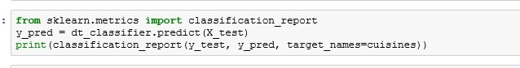
3.1 (c) Random Forest:
The Random Forest (Breiman, 2001) is an ensemble approach that can also be thought of as a form of nearest neighbor predictor.
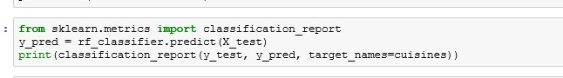
Ensembles are a divide-and-conquer approach used to improve performance. The main principle behind ensemble methods is that a group of “weak learners” can come together to form a “strong learner”. The figure below (taken from here) provides an example. Each classifier, individually, is a “weak learner,” while all the classifiers taken together are a “strong learner”.
The data to be modeled are the blue circles. We assume that they represent some underlying function plus noise. Each individual learner is shown as a gray curve. Each gray curve (a weak learner) is a fair approximation to the underlying data. The red curve (the ensemble “strong learner”) can be seen to be a much better approximation to the underlying data.
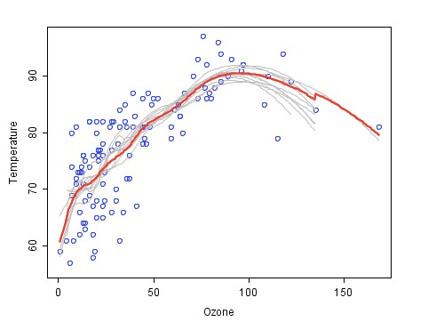

3.1 (d) Neural Networks:
Neural networks have long been used in problems such as this, with a lot of data, many variables, and the possibility of noise in the data.
Each input point is a high-dimensional vector. The neural network is organized in a series of layers (see figure), where the input vector enters at the left side of the network, which is then projected to a “hidden layer.” Each unit in the hidden layer is a weighted sum of the values in the first layer. This layer then projects to an output layer, which is where the desired answer appears.
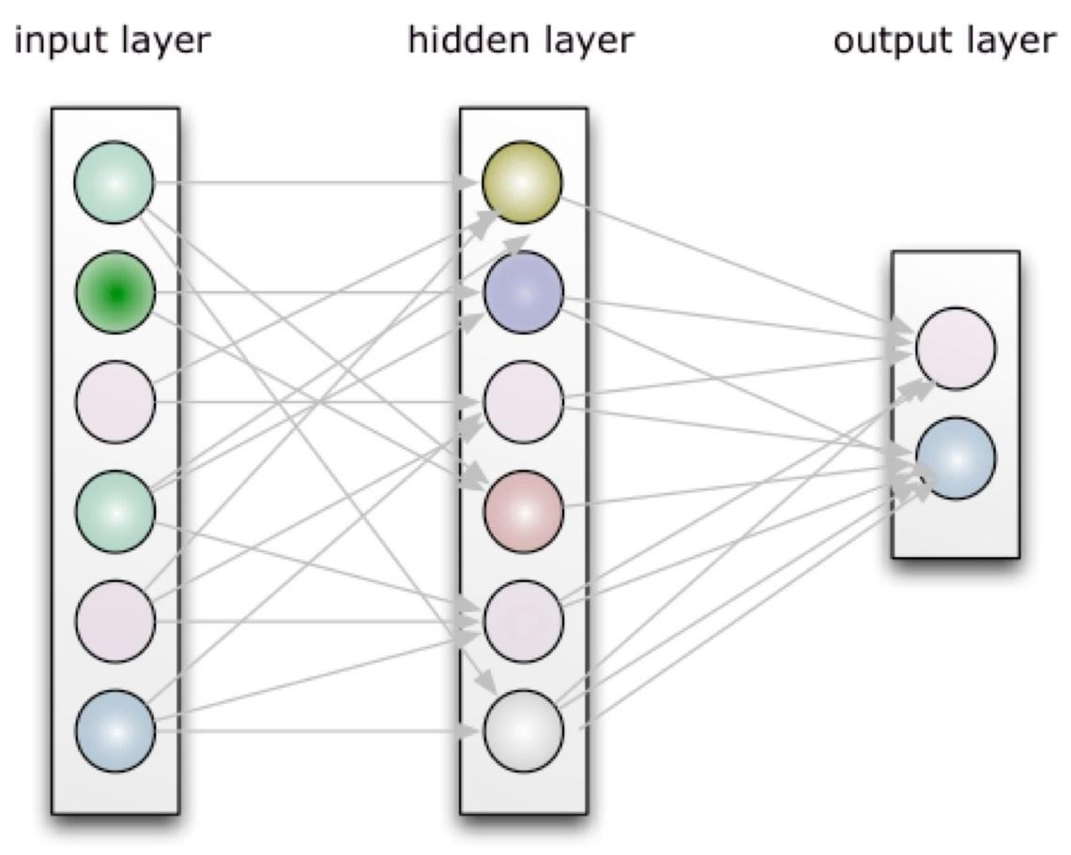
The network is trained with the input and the desired output, which in our case is whether the point represents a low click-through-rate (CTR) or high CTR keyword. Then training occurs:
weights at both the hidden and output layers are adjusted so that the actual output corresponds to the desired output. Once trained, the neural network should take a new data point and output either a zero (low CTR) or one (high CTR). If the classifier is uncertain it will produce a value somewhere in between.
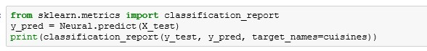

4. Model Assessment
4.1 Confusion Matrix Graphs
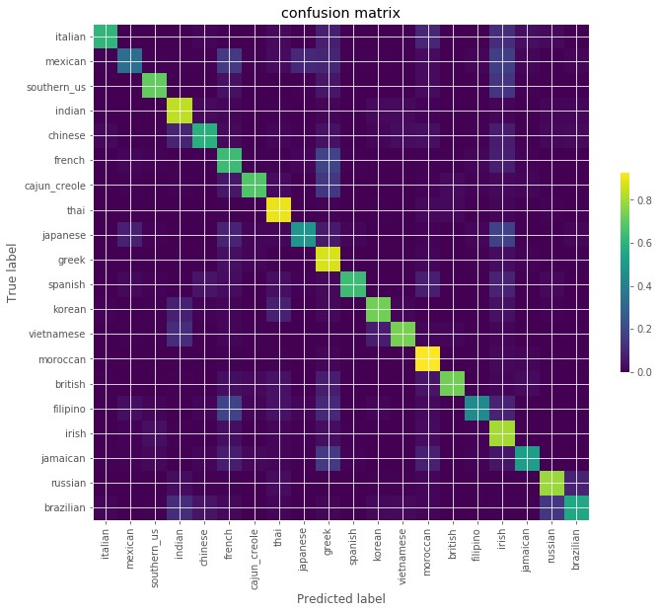

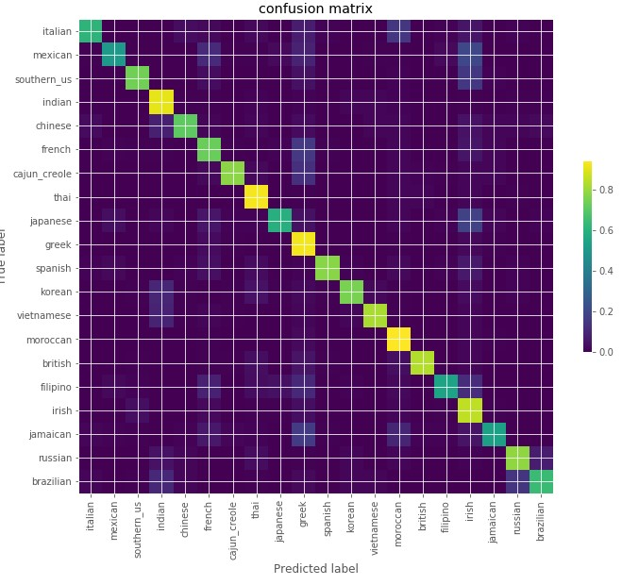

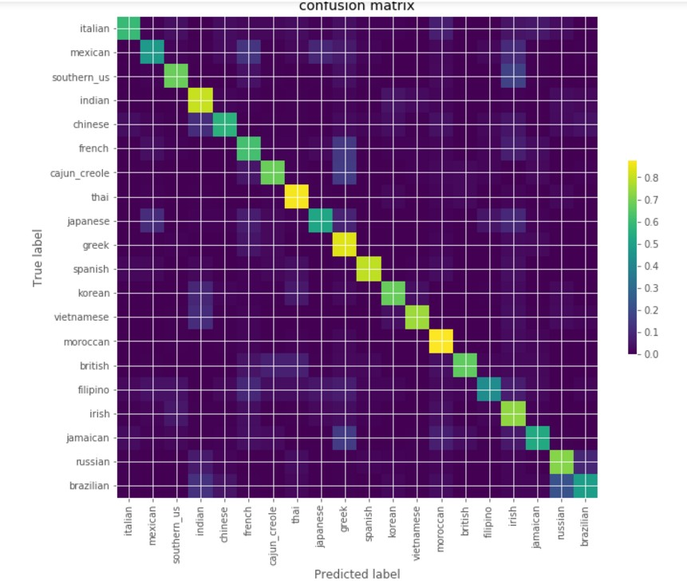

4.2 Model Results
The result of different predicted methods using Confusion Matrix.

Model | Logistic | Random Forest | Neural | Decision Trees
Type
Precision | 0.79 | 0.7 | 0.75 | 0.65
Recall | 0.79 | 0.7 | 0.75 | 0.65
F Score | 0.78 | 0.69 | 0.75 | 0.65

Since the Accuracy cannot explain the performance of our models properly. We measure the result of the models’ performances by precision rate and recall rate instead of the accuracy rate. It can be seen from the above chart. The logistic regression has the largest precision and recall rate among the four predicted methods. It means the logistic regression is more suitable for the dataset to predict.

5. Conclusion
Overview of our project
We found the problem of our project and used python to solve our problem. Then, we used data sampling techniques to balance variables so that it can be effective in our predictive models.
Business Implications of our project
- Improves Customer usability which can lead to increase in customer base.
- Increases authenticity of the website.
- Increases customer’s “Time spent on site”.
- Decrease in “Bounce rate” of the website.
- Increase in conversion rate for links, ads displayed on the website.

6. Future Recommendations
In our project, although we had precision and recall rate on our prediction, there was still something that we could not cover:
- For some cuisine, especially Italian cuisine, the data records are rare, some of them only have several hundred rows of data for us to predict, which would end up with inaccurate prediction.
- Also, because similar ingredients can belong to different cuisine, such as fried noodles in
Chinese cuisine and Pad Thai in Thai cuisine, it may influence the accuracy of our prediction.
- References
https://ischool.syr.edu/infospace/2013/04/23/what-is-text-mining/ http://blog.citizennet.com/blog/2012/11/10/random-forests-ensembles-and-performancemetrics http://www.real-statistics.com/logistic-regression/basic-concepts-logistic-regression/

- Appendix
Confusion matrix-confusion matrix is a table that is often used to describe the performance of a classification model (or "classifier") on a set of test data for which the true values are known.
Overfitting of model- In overfitting, a statistical model describes random error or noise instead of the underlying relationship.
Bounce rate- the percentage of visitors to a particular website who navigate away from the site after viewing only one page
Time spent on site- In Web analytics, including Google Analytics, average time on site is a type of visitor report that provides data on the amount of time (in minutes or seconds) visitors have spent on your website.
Precision- Precision refers to how close estimates from different samples are to each other.
Recall- Recall in this context is also referred to as the true positive rate or sensitivity,

